PARTICIPANT NOTES
Revitalize Your Presentations with a
21X20 PowerPoint
21 slides, 20 with no words, 420 seconds

by Peter Wickham

Contents

Workshop Instructions for Participants 1
21X20 PowerPoint Instructions for Participants 2
Specific Rules of 21 X 20 PowerPoint Presentations for This Workshop 3
21 X 20 PowerPoint Assessment 4
Feedback 5
Video clips presented 6
Appendix 1: Technical Notes for 21 X 20 Powerpoint 7
1. Open a PowerPoint file 7
2. New Slide 8
3. Number your slides 9
4. Adding a Picture. 10
a) Select the ‘Insert’ ribbon, and click on ‘insert picture’. 10
b) The other way to add a picture 12
5. Setting the Timing 14
6. Your Title Slide 14
7. Transition Options 15
8. Notes 15

Workshop Instructions for Participants

Participants need to bring their laptop computer and a camera if they have one. Remember to bring all power cords and adaptors that you may need over the whole workshop.
Bring a digital camera and any connections to your laptop needed to upload photographs onto your laptop. If you need a camera, you can arrange to partner with someone who does.
It is important that all participants be seated at the venue by the advertised starting time. Anyone who misses the first 3 hours will miss out on a lot of instruction on 21 X 20 PowerPoint.
You and your partner must report your names and the title of your presentation (on the one Assessment sheet you will be given per pair) to the Trainer before the end of the first workshop day.
Begin work on your 21X20 presentation with your partner as soon as possible. It takes time to decide on your themes, create a script that runs for exactly 420 seconds, find and arrange your slides, then practise practise practise!
Your turn to present your 21X20 PowerPoint will be announced about 10 minutes before you must begin. So be ready! Have your laptop turned on or your USB drive ready to plug in.
You will not be allowed to read from notes or see your laptop screen during your presentation.
See all the most recently updated material for this workshop at:
http://communicative.weebly.com/21-x-20-powerpoint.html
Leave comments or requests on the website’s Home Page to contact the author, Peter Wickham BEd (Edith Cowan University 2009) MEd (TESOL)(University of Wollongong 2010), Cert Tesol IV, Cert Teach, Dip Teach (Claremont Teachers College1973).

21X20 PowerPoint Instructions for Participants

1. Pair with a partner of your choice.
2. Decide on a theme that suits you and your partner. Hand to your Trainer the loose Assessment sheet (one sheet per pair) with your name, your partner’s name, and the title of your presentation.
(eg for trainees: haircuts, food, transport, characters in your class, lecturers, subjects in your course, locations on campus, recreation, activities, facilities, hobbies, social life, rules, prices, weather, a typical day, accommodation, etc)
(eg for lecturers; what makes a good student, courses, curriculum, daily schedule, the joys of teaching, dress codes, CPD, my colleagues, practicum, exams, marking, assessment, pedagogy etc)
3. Decide on the mood of your presentation (eg serious, humorous, informative, statistical etc)
4. Choose images for 20 slides that each tell an individual story within the theme.
5. Decide the order of the slides and which partner is going to present which slides.
6. Write a script that takes 20 seconds for each slide. Practise speaking while timing yourself. Edit the script of each slide to make it last exactly 20 seconds. The script must appear at the bottom of the screen on PowerPoint where it says “Click to Add Notes”, although you will not be able to see these during your presentation.
7. Set the Advance Slide setting to 20 seconds, and Apply To all. Deduct time set for any Transitions that you have chosen. Eg if your Transition takes 3 seconds, your Advance Slide setting should be 17 seconds.
8. Practise the whole 420 seconds with automated timing and NO SCRIPT VISIBLE.
Participants: Be present in TELLTraC Hall when your turn comes up, and attend all presentations. Your turn will be decided by random selection after each presentation. A panel of judges will assess presentations according to the marking rubric on Page 4 below.

Specific Rules of 21 X 20 PowerPoint Presentations for This Workshop

1. Each presentation consists of exactly 21 slides, automatically timed at 20 seconds per slide = 420 seconds of presentation. The number of seconds’ duration of any Transition is deducted from the 20 seconds of each slide, so that there is exactly 20 seconds between slides. The title slide alone will display words. The title slide will display the presentation title, the names of the presenters, and the date of presentation. Presenters may choose to talk or not to talk during these 20 seconds.
2. Topic: LIFE.
3. NO WORDS CAN APPEAR ON SLIDES WITH THE EXCEPTION OF THE TITLE SLIDE. Slides can show photographs, symbols, concept pictures, scanned drawings, patterns, colours, logos etc but no words except for words that incidentally appear in photographs. Any words that demand to be read will attract severe penalties (See Assessment Criteria).
4. NO NOTES, PALM CARDS OR ANY OTHER NOTES TO BE VISIBLE TO PRESENTERS.
5. NO SOUND RECORDINGS TO BE PLAYED.
6. Presenters speak on the subtopic of the slide for exactly 20 seconds.
7. Each partner presents exactly 10 slides for 20 seconds each.
8. Presenters must have their talk ready by the advertised beginning of presentations; presenters will be advised one presentation in advance that they are next.

21 X 20 PowerPoint Assessment

Eight judges communicate their assessment out of 10 or 20 to the Chief Judge immediately after each presentation. The Chief Judge will ensure that all marks are entered onto the following sheet.

Presenters: 1. 2.
Title of Presentation:
Quality and suitability of slides | /10
Staying on the topic | /10
Adhering to 20 slide format (minus 5 for each slide more or less than 20) | /20
Title slide shows title of presentation & names and class of presenters | /10
Speaking fluently and clearly enough for the audience to hear | /10
Adhering to 10 slides per presenter | /10
Adhering to 20 sec/slide. (* minus 1 for each pause of 5 seconds; minus I for each over-run of 5 seconds) | /20
Engaging presentation | /10
Total Marks  * Minus 50% per deliberate word on screen except for title slide | /100

Use this sheet as a checklist when preparing your presentation to make it as perfect as possible.

* Take special note of these penalties. Prepare and practise your presentation to avoid them!

Feedback

Please fill in your personal details, your ratings of your learning during this workshop, and any helpful comments or suggestions. Hand this to the Trainer at the end of the workshop.

21X20 PowerPoint Workshop Feed-back
Name of participant:
Venue: Date:
Having completed this workshop, to what extend are you now able to: (Please tick boxes below)
 | A lot | Some | A little bit | Not much | None
discern the central theme of your message
divide your message into sub-themes
present sub-themes separately and clearly
present without reading from a script
adhere to a timeframe when presenting
present a clear and concise message
present a message that is more engaging for the audience
Your comments:

Video clips presented

Pecha Kucha in the Classroom
Found at http://www.youtube.com/watch?v=5x5FB2mxvZY&feature=related
uploaded by RopyDavits 9 November 2010.
JALT in Nagoya

Pecha Kucha Presentation Tips
Richard Riche
www.oneclearmessage.com
found at http://www.youtube.com/watch?v=zAZ_8UJUpno&feature=related

Pecha Kucha on Pecha Kucha
Heike Philp
Found at http://www.youtube.com/watch?v=JZ4supn_I3g

Appendix 1: Technical Notes for 21 X 20 Powerpoint

This 21 X 20 PowerPoint presentation is going to be slightly different from other PowerPoint Presentations you may have prepared in the past. Below are some brief pointers about the technical matters, most of which you may be familiar with, and some that may be new to you.

1. Open a PowerPoint file

Firstly open a PowerPoint file. As the instructions say, click to add the first slide.

This is the title slide, and there is a box for a title and sub-title.
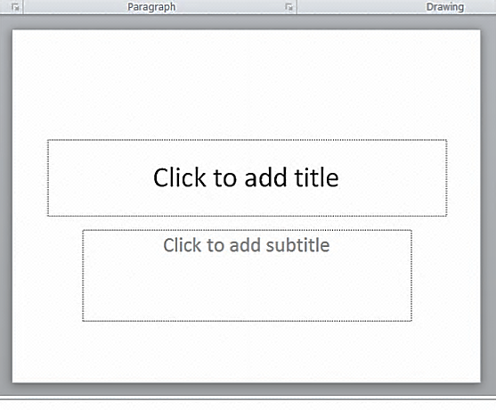

Type in the names of the presenters, the title of your presentation, your class designation (e.g. PPISMP 4) and the date (e.g. May 2012).
You may choose to add a background image to this slide, or insert a picture – see below how to add images – and you will need to make sure that your text remains clearly visible.
This is the only slide that will include any text.

2. New Slide

On the ‘Home’ ribbon click ‘new slide’.
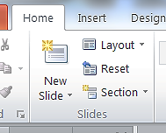

Next to that click on ‘layout’ and choose ‘blank’.
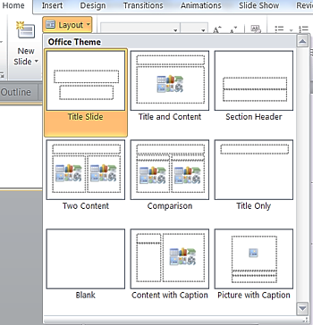

Continue to create new blank slides, 20 in total. There will be 21 slides including your title slide.

3. Number your slides

On the insert ribbon choose ‘slide number’. You may choose to check the box ‘don’t show on title slide’.

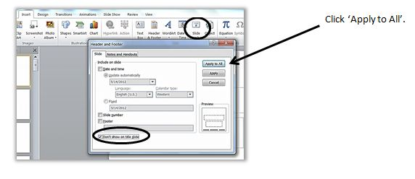

4. Adding a Picture.

There are two basic ways to create a picture slide.

a) Select the ‘Insert’ ribbon, and click on ‘insert picture’.

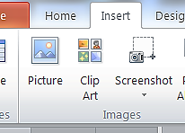

You will then have the opportunity to browse your computer for the picture you wish to add.
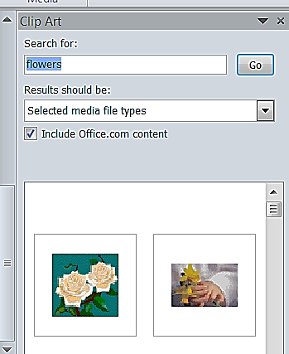
You can also choose to insert ‘clip art’ (as long as it fits with your theme). If you are connected to the Internet a panel will open at the right for you to choose clip art from.

If you have the latest version of Office, you can also insert a screen shot. You need to have the screen you wish to take a shot from open on your desktop and then open your PowerPoint file over the top of it.
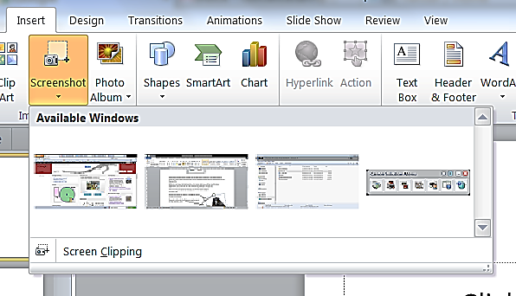
You will be shown which windows are already open on your desktop and be asked to choose the one you want. Then the screen will go milky and you can select the section of the screen you want.

Adjusting your picture
When you insert your photo/picture/clip art (or screen shot), you will then need to make adjustments to it, so that it fits the slide well and has good impact for your talk.
After you insert your picture (or clip art), you will then need to adjust it to fit your slide.
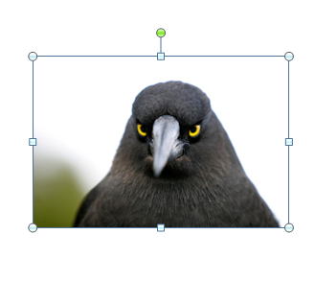
Click on your picture to ‘select’ it, and drag the corners to make it fit the slide.
If you pull on the sides it will make your picture go out of shape and look weird.
You can use the green button at the top to turn your picture on a different angle, which may make it more interesting.

With your picture ‘selected’, you can also now use the options on the ‘Format’ ribbon.
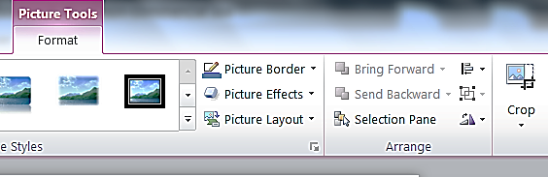

You can now choose a border or effect, align it within the slide, flip or rotate it, and crop it.

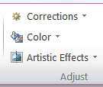
On the left-hand end of the Format ribbon you can also choose some minor enhancements to your picture, such as corrections (sharpen and soften) and interesting artistic effects (as long as they fit your theme!)

b) The other way to add a picture

As long as you don’t need to make any adjustments to your picture, then it can be added as part of the background design. (Then you choose whether to apply it to all slides or just the one.)
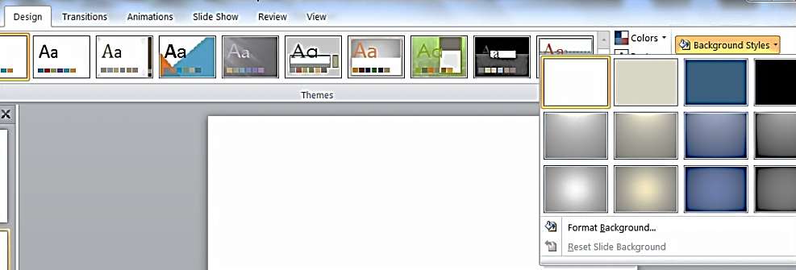
On the ‘Design’ ribbon, click on background styles, and go to format background.

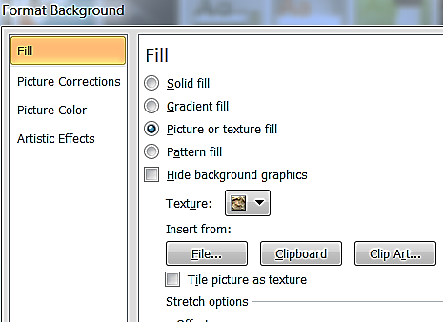
In the dialogue box, choose ‘picture or texture fill’.
Click on ‘File’ to browse your computer for the picture you want to insert.
The picture will be inserted as the background of the slide, fitting perfectly without further adjustment. BUT if the picture is the wrong shape it will automatically be cropped (rather than stretched) and you need to make sure the important part is visible.
Uncheck the ‘Tile Picture as texture’ box.
IMPORTANT
In this situation, make sure not to click on the “apply to all” button at the bottom. Click ‘Close’.
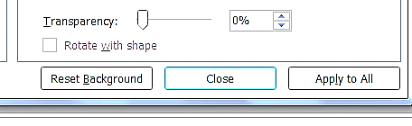

5. Setting the Timing

This is the important part of your 21 X 20 PowerPoint presentation.
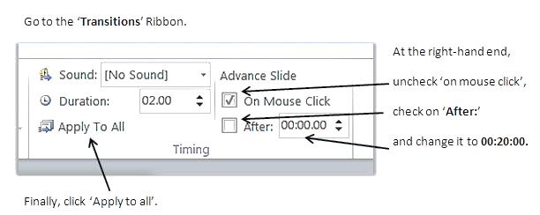

6. Your Title Slide

We don’t want your title slide to be only visible for 20 seconds, in case there is some kind of delay, so you need to change the timing setting just for that one slide.
Now go back to your title slide, open the ‘Transitions’ ribbon and re-check ‘on mouse click’, and un-check the ‘After’ option.
When you give your presentation the title slide stays in place until you are ready to start your talk.

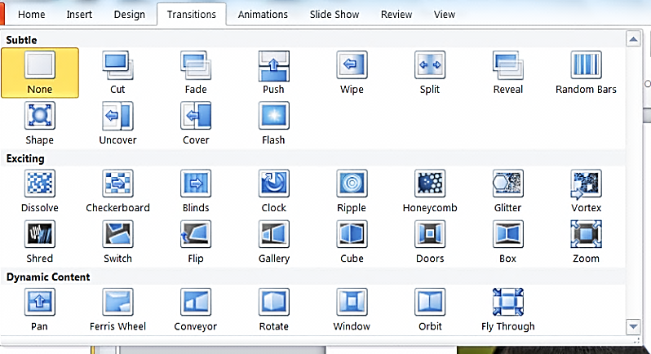
7. Transition Options

You might also like to choose one/some interesting transitions between your slides, although this is not essential to your 21 X 20 PowerPoint presentation and you need to consider whether or not it will simply be a distraction. Subtract the duration of transitions from the 20 seconds for each slide to give your new time allowance for each slide.

8. Notes

